**“Instructions for run the server and screenshots for the project”**

* To run the server kindly look at the **info.md** file in the project folder, to know about the details related to the package installations and their updated versions, so that you can easily start and run the server and be able to check the **Backend**.
* I also create the client application(react app) but not starting the work on it. I just create it for the future related remaining **Frontend applications** and then map it with the backend.
* To check/test the routes/middlewares, first you have to register user/add admin, then signin and make sure that you test the routes/middlewares within 24hours. Because after 24hours jwt(jsonwebtoken) will be expired because I set it to ‘1d’.
* When you see the project you will find that I defined different roles, Schema and models for users and admins.It’s basically a platform for articles lovers where people can read , write and publish their articles and according to the person role(either ‘user’ or ‘admin’), people persons have different accesses
* **Below are the screenshots just to show you my work, for programming/coding related details you can see the backend folder:**

**Database for admins**

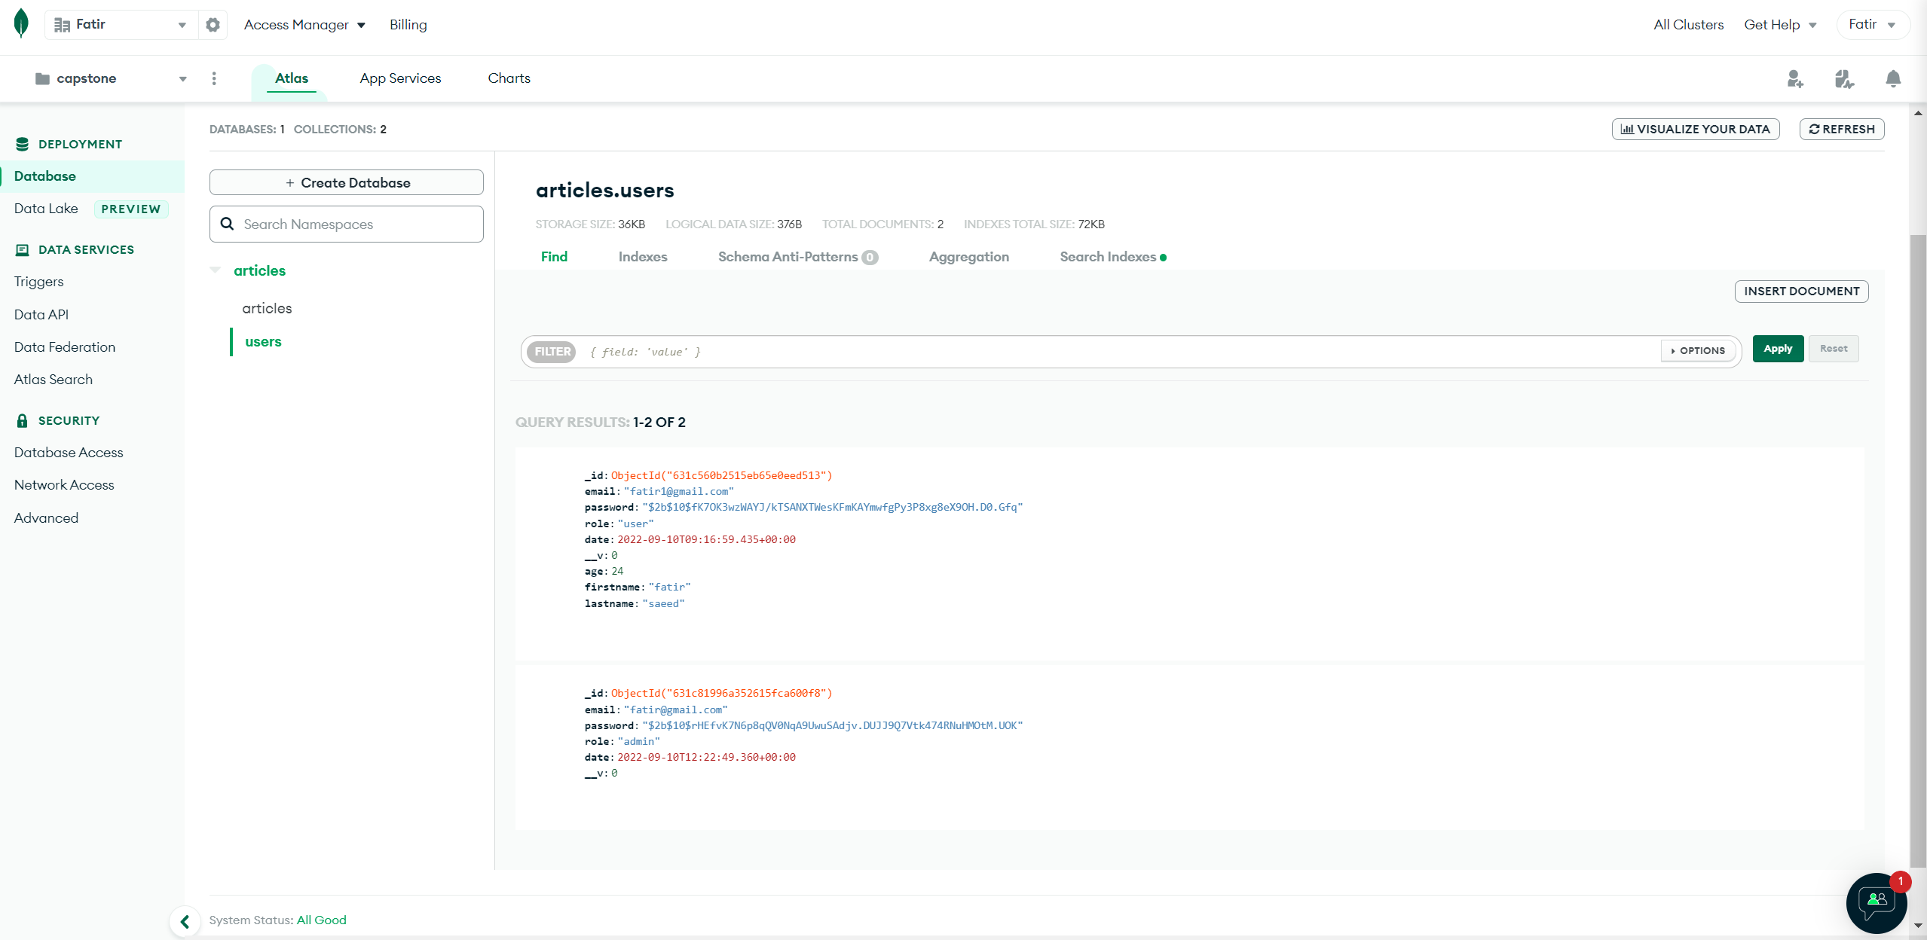

**Database for users**

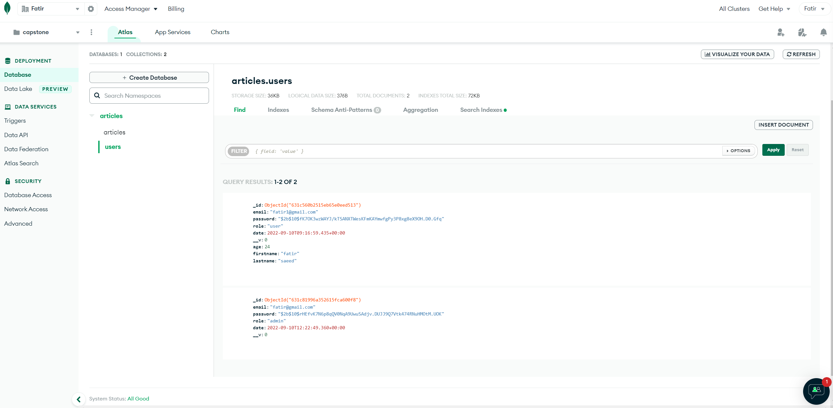

**Testing of Backend for different routes using postman**

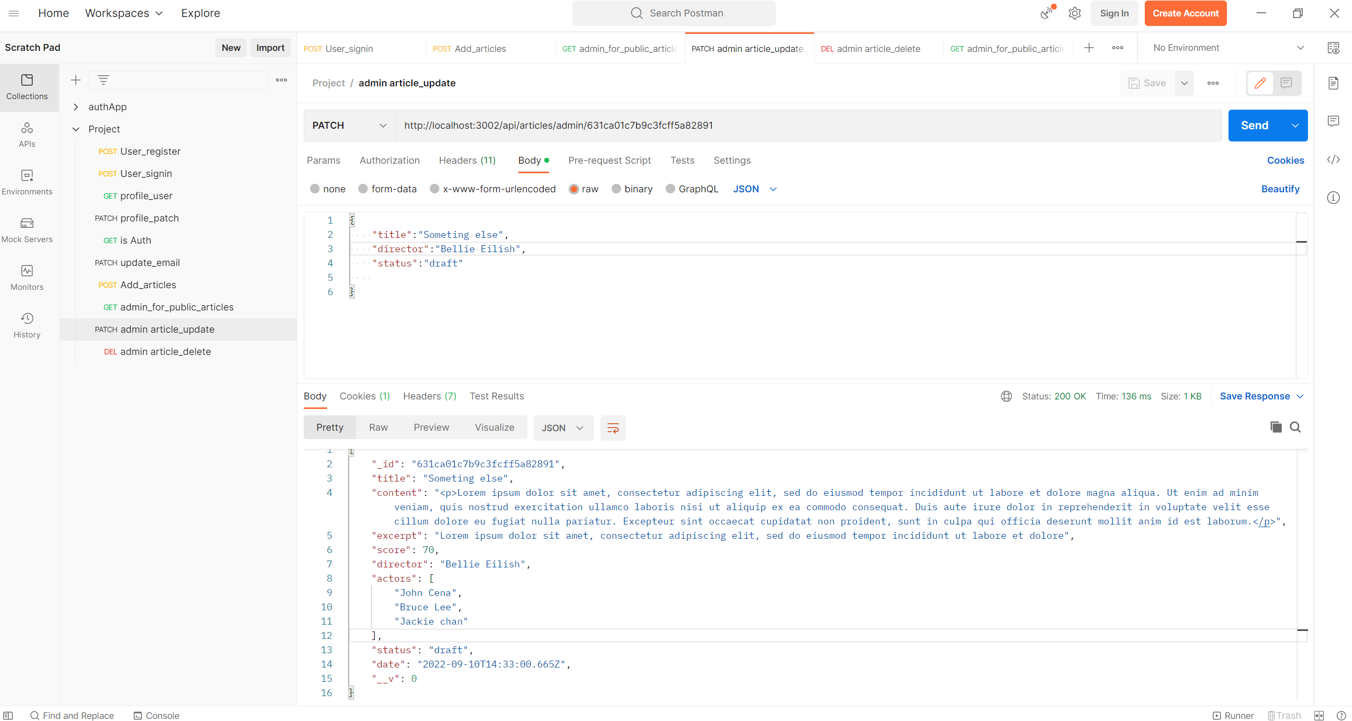

**\*\*\*\*\*\*\*\*\*\*\*\*\*\*\*\*\*\*\*FINISH\*\*\*\*\*\*\*\*\*\*\*\*\*\*\*\*\*\*\***